**Smart Wallet Project Proposal**

Ramón Rosado Javier Ortiz

Jan Culpeper Edgar Rivera

Miguel Vazquez Hector Jimenez

**Project Summary**

A design and development project for users wishing to handle their receipts more efficiently. Project will consist of a GUI that will allow users to create their profiles, log their receipts, organize them, and request them, as well as a database to store this information. The team mentioned above will begin the design, implementation, and testing of the project which will take approximately one semester to complete.

**Project Background**

The current situation is that consumers do not have an efficient and effective mean of handling and tracking their purchases as well as storing transaction information, such as receipts, electronically. At the same time, consumers do not have an adequate mean of browsing for the receipts they wish to view as well as search for specific transactions. This creates a need for a system that allows consumers to create a personal profile for which will allow them to store their receipts virtually, browse collection, search for receipts, and view them when necessary.

**Project Objective**

The project’s objective is to develop a platform that provides a better method of handling important information about business transactions for customers by allowing them to store their receipts on their personal account, as well as reducing the need of paper, impacting positively the environment. It is also critical to provide a safe and reliable system to store user’s personal information as their safety is one of our main priorities. The project should also be visually appealing and as simple as possible to use so that user satisfaction is achieved.

**Project Scope**

To implement an app with a user interface that starts by prompting the user for their login credentials and, once validated with the database, takes them to the main page where they can manage their receipts, browse their collection, search for specific transactions and view them. The system will also consist of other pages for the creation of user profiles, processing and handling of payments, and for providing feedback for transactions. The project will be developed following an agile methodology; more specifically, a scrum implementation where 2-3 meetings will be held weekly to assure project development is being accomplished.

**Project Architecture**

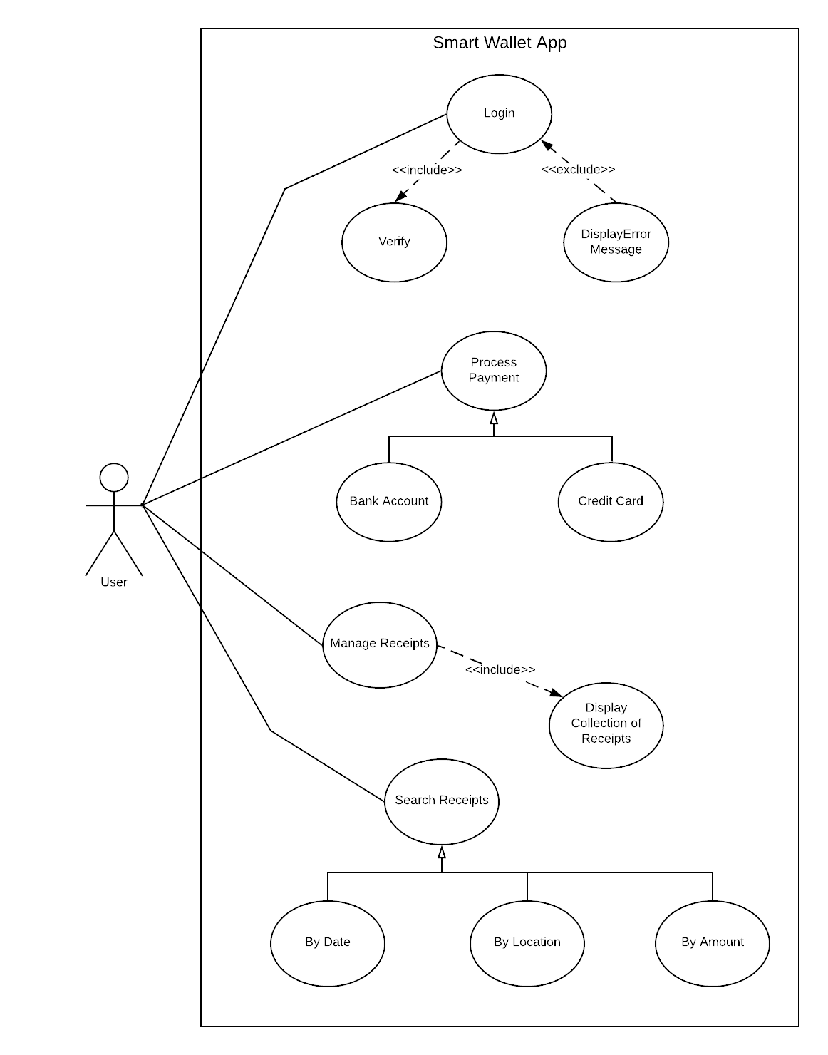

**Use Case Description:** There will be various scenarios of usage with our app, the first one will always be the user login into their account or creating one if necessary. When this happens, the system will prompt the user for their credentials which will then be validated with the system’s database and, if correct, the user will be taken to the main page of the app; otherwise an error message will be displayed and the user will be prompted for the credentials once again. After reaching the main page, the user can choose to process any payment required for which there are many ways to do so, as with a bank account or a credit card. If the user chooses to manage their receipts, a collection of their receipts will be displayed from which they can search them using various criteria like filtering by date, by location, or by amount of transaction.  
**Project Model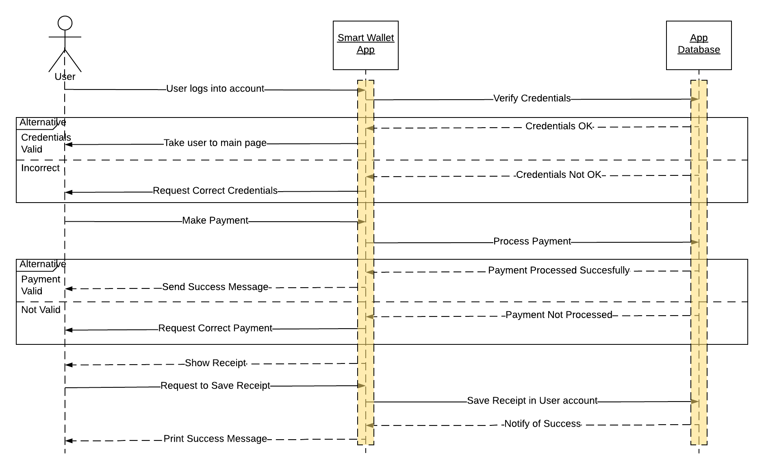Sequence Diagram Description:** This model covers how the user will interact with the system when login in, making a payment and how the system stores the receipts with the database. As mentioned, the app will begin by prompting the user for their login credentials, for which the app will verify them with the database. If they prove to be correct, then the user will be taken to the main page; otherwise they will be requested with the correct information. At the main page, the user can request to do various actions like, for example, making a payment. If this option is chosen, then the app will process the payment with the database to make sure they are enough funds or information is correct. Once validated, the app will display a success message to the user to notify of progress or request the correct information. After the transaction is processed, the user will be shown the receipt of purchase and, if they request to, save the receipt in their collection. Finally, the app will communicate with the database to store said information and, after completion, the customer will receive a message notifying of success of operation.